------------------------------------------------------------
مرحلۀ اول
------------------------------------------------------------

Entropy(D1) = -4/10 * log2(4/10) - 6/10 * log2(6/10) = 0.9710

Domain(Age) = {Old, Middle, Young};
Entropy_Age(D1) = 4/10 * (-3/4 * log2(3/4) - 1/3 * log2(1/3))
+ 3/10 * (-2/3 * log2(2/3) - 1/3 * log2(1/3))
+ 3/10 * (-1/3 * log2(1/3) - 2/3 * log2(2/3)) = 0.8868;

Domain(Income) = {High, Medium, Low};
Entropy_Income(D1) = 4/10 * (-4/4 * log2(4/4) - 0/4 * log2(0/4))
+ 4/10 * (-1/4 * log2(1/4) - 3/4 * log2(3/4))
+ 2/10 * (-1/2 * log2(1/2) - 1/2 * log2(1/2)) = 0.5245;

Domain(Job) = {Teacher, Student};
Entropy_Job(D1) = 5/10 * (-3/5 * log2(3/5) - 2/5 * log2(2/5))
+ 5/10 * (-3/5 * log2(3/5) - 2/5 * log2(2/5)) = 0.9710;

Entropy(D1) – Entropy_Age(D1) = 0.9710 - 0.8868;
Entropy(D1) – Entropy_Income(D1) = 0.9710 - 0.5245;
Entropy(D1) – Entropy_Job(D1) = 0.9710 - 0.9710;
تقسیم بر اساس دریافتی.
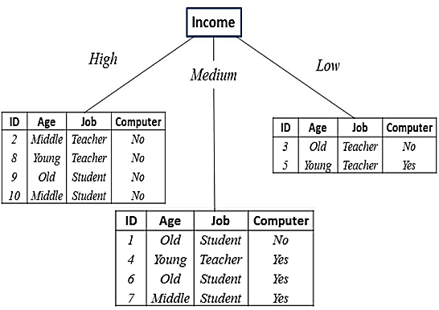
------------------------------------------------------------
مرحلۀ دوم
------------------------------------------------------------
Entropy(D2_1) = -4/4 * log2(4/4) = 0
------------------------------------------------------------

Entropy(D2_2) = -1/4 * log2(1/4) - 3/4 * log2(3/4) = 0.8113

Domain(Age) = {Old, Middle, Young};
Entropy_Age(D2_2) = 2/4 * (-1/2 * log2(1/2) - 1/2 * log2(1/2))
+ 1/4 * (-0/1 * log2(0/1) - 1/1 * log2(1/1))
+ 1/4 * (-0/1 * log2(0/1) - 1/1 * log2(1/1)) = 0.5000;
Domain(Job) = {Teacher, Student};
Entropy_Job(D2_2) = 1/4 * (-0/1 * log2(0/1) - 1/1 * log2(1/1))
+ 3/4 * (-1/3 * log2(1/3) - 2/3 * log2(2/3)) = 0.6887;
Entropy(D2_2) - Entropy_Age(D2_2) = 0.8113 - 0.5000;
Entropy(D2_2) - Entropy_Job(D2_2) = 0.8113 - 0.6887;
تقسيم بر اساس سن.
------------------------------------------------------------

Entropy(D2_3) = -1/2 * log2(1/2) - 1/2 * log2(1/2) = 1

Domain(Age) = {Old, Young};
Entropy_Age(D2_3) = 1/2 * (-1/1 * log2(1/1) - 0/1 * log2(0/1))
+ 1/2 * (-0/1 * log2(0/1) - 1/1 * log2(1/1)) = 0;

Domain(Job) = {Teacher};
Entropy_Job(D2_3) = 2/2 * (-1/2 * log2(1/2) - 1/2 * log2(1/2)) = 1;

Entropy(D2_3) - Entropy_Age(D2_3) = 1 - 0;
Entropy(D2_3) - Entropy_Job(D2_3) = 1 - 1;
تقسيم بر اساس سن.
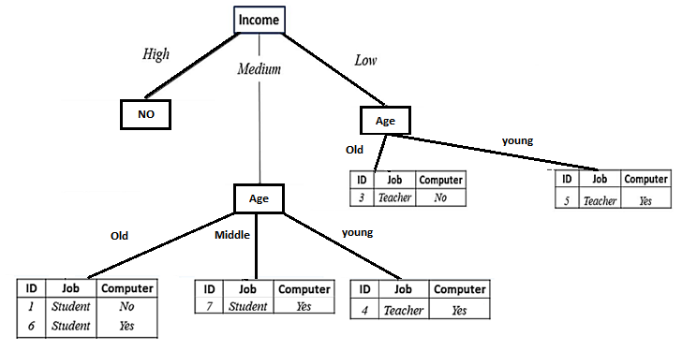
------------------------------------------------------------
مرحۀ سوم
------------------------------------------------------------
Entropy(D3_1) = -1/2 * log2(1/2) - 1/2 * log2(1/2) = 1

Domain(Job) = {Student};
Entropy_Job(D3_1) = 2/2 * (-1/2 * log2(1/2) - 1/2 * log2(1/2)) = 1;
Entropy(D3_1) - Entropy_Job(D3_1) = 0
Entropy(D3_2) = -1/1 * log2(1/1) = 0
Entropy(D3_3) = -1/1 * log2(1/1) = 0
